Osteoblast
From Wikipedia, the free encyclopedia
Osteoblast (from the Greek combining forms for "bone", οστό, ostō and βλαστάνω, blastanō"germinate") are cells with single nuclei that synthesize bone. However, in the process of bone formation, osteoblasts function in groups of connected cells. Individual cells cannot make bone, and the group of organized osteoblasts together with the bone made by a unit of cells is usually called the osteon; the basis of this is discussed in "Organization and ultrastructure of osteoblasts" below.
In organized groups of connected cells, osteoblasts produce a calcium and phosphate-based mineral that is deposited, in a highly regulated manner, into the organic matrix forming a very strong and dense mineralized tissue - the mineralized matrix. This is further discussed in "Mineralization of bone" below. The mineralized skeleton is the main support for the bodies of air breathing vertebrates. It also is an important store of minerals for physiological homeostasis including both acid-base balance and calcium or phosphate maintenance.^{[2][3]}

http://apbrwww5.apsu.edu/thompsonj/Anatomy%20&%20Physiology/2010/2010%20Exam%20Reviews/Exam%202%20Review/Ch%206%20Bone%20Histology.htm
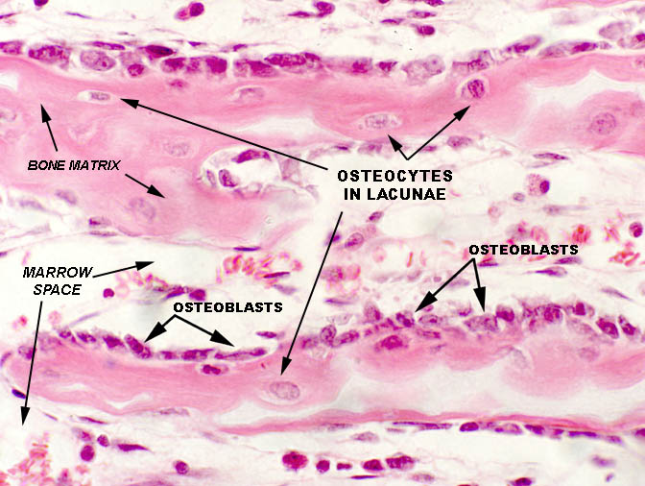
osteoblasts - The stem cells from which bone tissue develops; bone-forming cells; located in the periosteum and endosteum of bones; these cells play an active role in bone growth and development, in remodeling and repair, and in blood calcium and phosphate ion homeostasis;
osteocytes - The mature cytoplasmically-branched bone cells embedded within lacunae in the matrix of mineralized bone tissue; these cells play an active role in blood calcium and phosphate ion homeostasis;
osteoclasts - The specialized bone cells which have the capacity to enzymatically dissolve bone tissue; located in the periosteum and endosteum of bones; these cells play an active role in bone remodeling and repair and in blood calcium and phosphate ion homeostasis;

Bone contains three specialized cell types. The name of each begins with osteo, since this is the Greek word for bone. Osteoblasts are cells that form new bone. They are found on the surface of new bone and they have a single nucleus (Figure 4). They are derived from stem cells in the bone marrow. Osteoblasts produce collagen found in bone and the proteoglycans found in ground substance. They are rich in alkaline phosphatase, a phosphate-splitting enzyme required for bone mineralization, a process that osteoblasts control. When osteoblasts have completed making new bone, the cells take on a flattened appearance and line the surface of the bone. Now in a more mature, less active state, the cells are called bone-lining cells. They still serve important functions, however. For instance, bone-lining cells respond to specific hormones and produce proteins that activate another type of bone cell called the osteoclast.
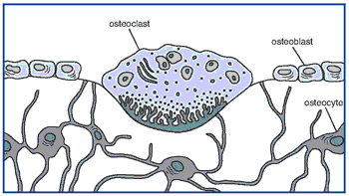
Figure 4. An osteoclast, osteoblasts, and osteocytes (across the bottom).
Osteoclasts are large, multinucleated cells that are capable of movement. They are formed by the fusion of mononuclear cells derived from stem cells in the bone marrow. Unlike osteoblasts, osteoclasts lie in depressions where their function is to dissolve (resorb) bone and help shape it (Figure 4). They begin by attacking the mineral portion of bone and then they degrade the bone proteins.
Osteocytes are cells that reside inside bone. They are derived from osteoblasts as new bone is being formed and then become surrounded by the new bone. However, rather than being isolated, osteocytes communicate through long branches that connect these cells to one another. These cells regulate the response of bone to its mechanical environment.⁵³ Osteocytes sense pressures or cracks in bone and help direct osteoclasts to locations where bone will be remodeled.
https://science.education.nih.gov/supplements/nih6/Bone/guide/info_musculo_skin-a.html

